UET DSL INTERNET ACCESS FORM

Name
Designation
Address
E-Mail Address
Phone Office
Phone Residence
PC MAC Address
IP Address (To be assigned by Computer Cell )

* DSL Modem will be arranged by user. Any modem can be used but preferred model is:
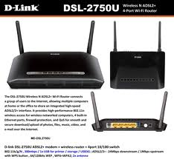
D-Link DSL 2750U

Sig.

Head/Chairman Sig.

